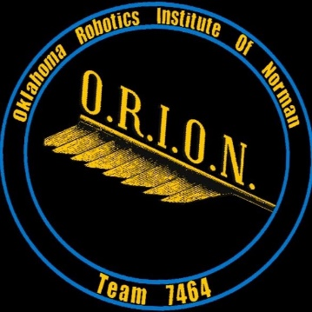

**Oklahoma Robotics Institute Of Norman**

**Team O.R.I.O.N. Sponsorship Packet**

FIRST Robotics Competition Team 7464

FIRST Core Values

We express the *FIRST*philosophies of *Gracious Professionalism* and *Coopertition*

through our Core Values:

* **Discovery:***We explore new skills and ideas.*
* **Innovation:***We use creativity and persistence to solve problems.*
* **Impact:***We apply what we learn to improve our world.*
* **Inclusion:***We respect each other and embrace our differences.*
* **Teamwork:***We are stronger when we work together.*
* **Fun:***We enjoy and celebrate what we do!*

FIRST Mission

The mission of *FIRST®* is to inspire young people to be science and technology leaders and innovators, by engaging them in exciting mentor-based programs that build science, engineering, and technology skills, that inspire innovation, and that foster well-rounded life capabilities including self-confidence, communication, and leadership.

What Is FIRST?

FIRST is For Inspriation and Recognition of Science and Technology. FIRST is an organization created to encourage kids to innovate and lead, addressing challenging problems in new and intelligent ways by creating a robot game for which teens design and build a robot and manage the team like a small business.

Working on a FIRST Robotics team is “the hardest fun you’ll ever have!”

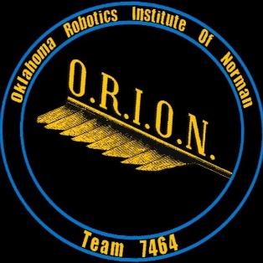

About Our Team

Our team is a 4H club out of Norman, OK. We just completed our first competition and are proud to share that we earned the highest award available to a rookie team, the Rookie All-Star award. This award is not awarded unless a rookie team demonstrates an exceptionally strong organization with a well-engineered robot, a connection to the community, and demonstration of FIRST core values. The Rookie All-Star award earned us an invitation to the world championship competition in April. We are proud to represent our region as a rookie team to the best teams from around the world.

Team ORION is honored to have several excellent sponsors, but we are still in need of more. As a new team, we need to build our inventory of robot parts such as transmissions, wheels, motors, belts, chains, beams, wires, and hardware. Additionally, participation in events comes with a cost. We are proud to be good stewards of our finances and our sponsors’ generosity. We look forward to building a strong enough team to recruit more highschoolers from around the county to our program. We hope you will consider making a tax-deductible donation to our 4H club so we can continue to innovate.

**Skills that ORION students have already learned:**

Designing

Our students designed how the robot functions while adhering to strict guidelines. We hope to learn how to use CAD next year.

Building

Many kids used various power tools for the first time.

Electronics

The control board for our robot was built and wirepathed by teens.

Coding

Our team programs our robot using C++ language. This has been a wonderful learning experience for the team.

Business Skills

Our students have been challenged to create a business plan for their team.

Robert’s Rule of Order

The team has learned how to make group decisions with order and fairness.

**Impact of FIRST on Students**

**The Project-based learning of FIRST Robotics has many benefits for students**

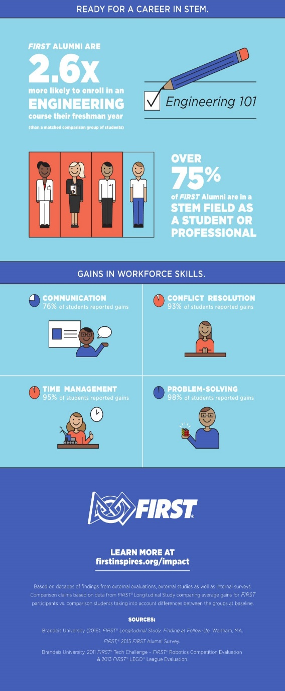“Being on an FRC team has helped me learn so much. Not only all that goes into building a working robot, but other things I never would’ve expected to learn from this team. Throughout this past season I’ve organized a business model, done some public speaking, and scheduled and done outreach. I have learned how to effectively share my ideas, and how a team collaborates to make decisions.” -Laurel, age 16

“I am proud of a group of friends coming together with an idea and actually working to make the idea happen. I feel FRC helps prepare you for your future, no matter what career you’re heading into. Learning new technology and getting closer to my friends are my favorite parts of FRC.” - Matt, age 14

“It’s crazy fun. You learn tons of valuable life skills like working under time constraints, how to properly use power tools, safety, and the decision-making process. What I did that made me so proud was developing the website and facebook page and helping our community via the food bank service project.” – Josh, age 15

“My favorite part of FRC is competitions because I love seeing what other teams have been working on. We have made some friends on other teams, so it’s fun to see them and cheer for them as well as compete against them.” -Emilia, age 14

”

-Emilia

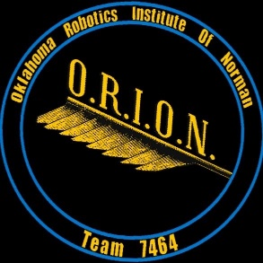

O.R.I.O.N. 2018-19 Budget

.

Participation in FRC means we are building 120 pound robots out of actual machined parts. It means we are learning how to use technology to fabricate and how to use tools necessary in the real world. Because of this, it takes a lot of money to make a team function. This helps us learn how to budget and manage our money soundly.

TESLA SPONSOR

$3,000 OR MORE DONATION

* Large logo on shirts
* Logo on the robot
* Logo and link on team website and social media sites
* Thank you plaque
* Invitation to a private dinner with a demonstration of the robot and visit with the team.

EINSTEIN SPONSOR

$1,000-$2,999 DONATION

* Medium logo on shirts
* Logo on the robot
* Logo and link on team website and social media sites
* Invitation to a sponsor reception with robot demonstration.

NEWTON SPONSOR

$500-$999 DONATION

* Business card-sized logo on shirts
* Logo and link on team website and social media sites
* Invitation to a sponsor reception with robot demonstration.

SPONSOR

$25-$499

* Name listed on shirts
* Logo on team website
* Photo thank you card

INCOME

Sponsorships paid to FIRST: $11,000

Sponsorship money on hand: $1,450

Money paid out of pocket: $487

Total Income: $12,937

EXPENSES

Regional Registration and

basic robot kit of parts: $6,000

Robot parts expenses: $1,937

World Championship

Registration: $5,000

Total Expenses: $12,937

You may contact the team coach any time for more information.

Amanda Hall

Mrs.Hall.Amanda@gmail.com

(405) 613-0702

We humbly thank you for your time and consideration. We think this team can grow to serve many families, and that the positive impact on them will be extraordinary. We are proud to serve our community in various ways and would love the chance to share more about what we do and what our goals are.

Please consider a tax-deductible donation to our team. Your sponorship will be used to build up our inventory of parts and help us pay for competition entrance fees. FIRST offers many scholarships for FRC students, so their success as a team leads to opportunities in higher education and in life.

You may support our team by writing a check to:

Cleveland County 4H Foundation

Attn: Melody Schrank

Memo: ORION Robotics #7464

601 E. Robinson St.

Norman, OK 73071

(405) 321-4774

Our goal is to serve families of any means. We hope to secure enough sponsors that we do not have to be a burden on the families whose children join our team. We believe STEM learning and project-based robotics should be available to all families in our 4H service area.